LAMS Start-Up Procedure

ARISTO17, 1/26/2017

# General Info

LAMS is mounted on the left-wing outboard inboard location of the GV for the ARISTO17 project. The instrument is setup in the 4-beam configuration, utilizing a similar setup as flown in ARISTO16 (same optics, same 4-ch LAMS4-Rev.4 data capture card). Due to the use of the LAMS4-Rev.4 card, the instrument requires:

* The on-card FPGA must be programmed after every power cycle
* Data output from the instrument must be monitored periodically to verify proper operation, particularly when operating from an unreliable power source.

# Pre-Startup Verification

* Verify that the Xilinx Platform II programming unit (USB, red box) is mounted with the in-rack chassis and that a USB cable connects the programming unit to the rack’s PC

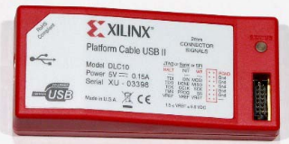

* Verify that the rack PC is marked specifically for “LAMS” and that the PC has the Xilinx iMPACT software installed.
* Verify that the instrument power supply switch (red) is turned ON. The switch location is atop the power supply unit mounted at the back of the in-rack chassis. The switch may not be easily accessible after rack installation so it may remain ON.

# Startup Procedure

1. **Apply 120V/60Hz power** to the instrument power supply (mounted atop the slim in-rack chassis that contains the data capture card electronics)
2. **Boot the PC and start the Xilinx iMPACT software** (used to program the FPGA)
   1. An “iMPACT” icon should be available on the PC desktop
3. The iMPACT software will prompt the user to create a new project or to open the previous project. **Select to open the previous project.**
   1. When the project opens, the main frame should become filled with two devices as shown below in Figure 1.
   2. The xc6vtx240t device should be associated with a \*.bit file. This file may be called “lams\_wrapper.bit” or “lams\_four\_beam\_wofil.bit”
4. **R-click the xc6vtx240t device icon and select “Program”**
   1. A progress window will appear and may take ~20sec to complete.
   2. After completion, minimize this window to keep it readily available
5. **Press the black “reset” button on the in-rack chassis**. In the ARISTO17 rack configuration, the switch is not directly visible but is located on the back of the chassis on the **right side** (when facing the computer).
   1. **CAUTION: There are exposed 120V connections to the instrument power supply on the left side rear of the chassis. Besides this, the reset switch may be located near other live connections. Use caution when accessing this button.**
6. **Open the Aeros software and monitor LAMS data as a histogram**

# Power Failure Re-Start Procedure

In the case of a power failure, the FPGA on the LAMS data capture card will become reset and must be reprogrammed. Follow the instructions above to bring the instrument back into normal operation.

# Monitoring Data for Proper Operation

The LAMS instrument may be sensitive to power glitches that can cause the FPGA to become reset. The output spectrum data should be monitored to ensure normal operation.

* Periodically look at the data as a histogram in Aeros. The data will vary as conditions change but may look similar to the data in Figure 2 or Figure 3.
* Having a technician briefly look at the data on a 10-20min interval is sufficient
* If the data becomes “All 0’s” across the entire histogram, then data capture has failed. Follow the “Startup Procedure” to bring the instrument back to normal operation.

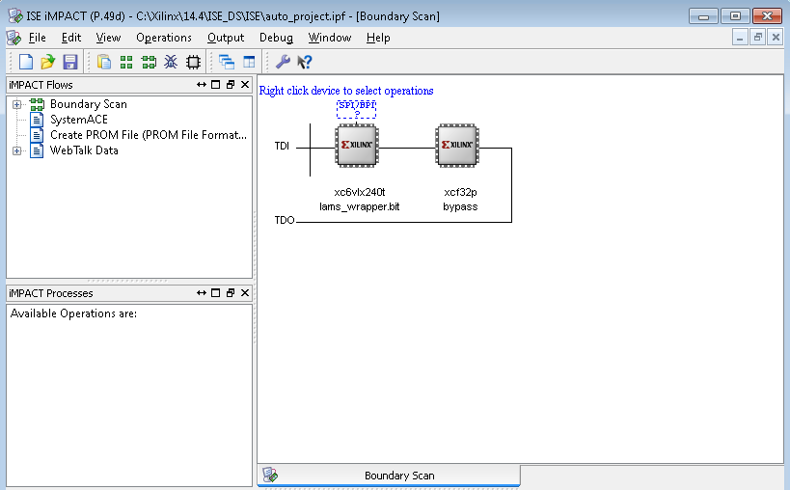

Figure 1 iMPACT Configuration for LAMS

|  |  |
| --- | --- |
| C:\Users\jcarnes\Documents\Projects\LAMS\data\aristo17_prep_debug\IMG_1455.JPG  Figure 2 LAMS Data for mid flight speeds | C:\Users\jcarnes\Documents\Projects\LAMS\data\aristo17_prep_debug\IMG_1456.JPG  Figure 3 LAMS data for slow flight speeds (note the “elbow” near the axis origin) |